**CHAPTER III**

**PROBLEM ANALYSIS**

**III.1 How to Install SQL Server**

1. Choose the Bit on your computer

Figure 3.1 SQL File.exe

1. Choose New Installation if you never install SQL Server

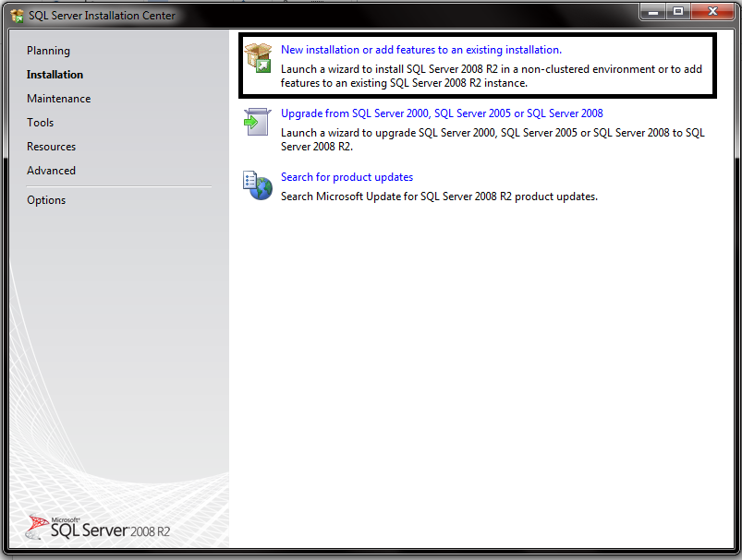

Figure 3.2 First Appearance of SQL Server Installer

1. Click Accept Terms.

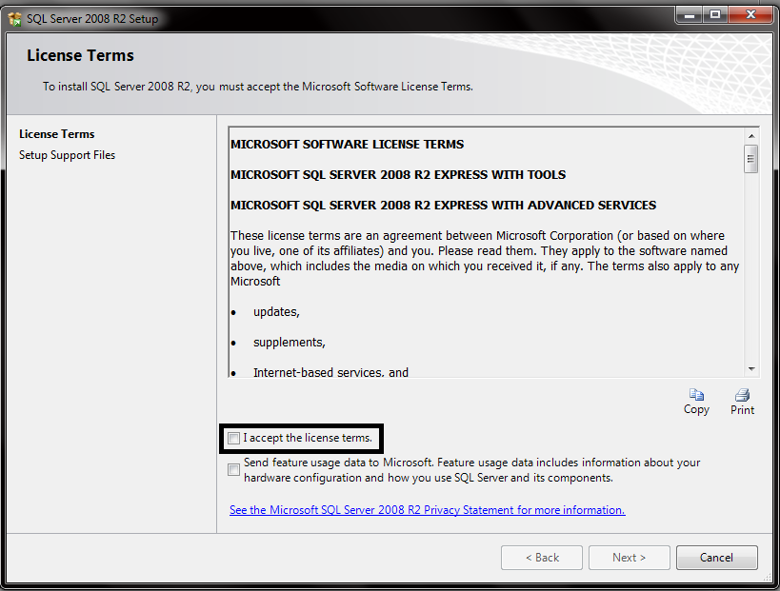

Figure 3.3 License Terms of SQL Server

1. Select All Features , choose the feature directory place on your computer and Click next.

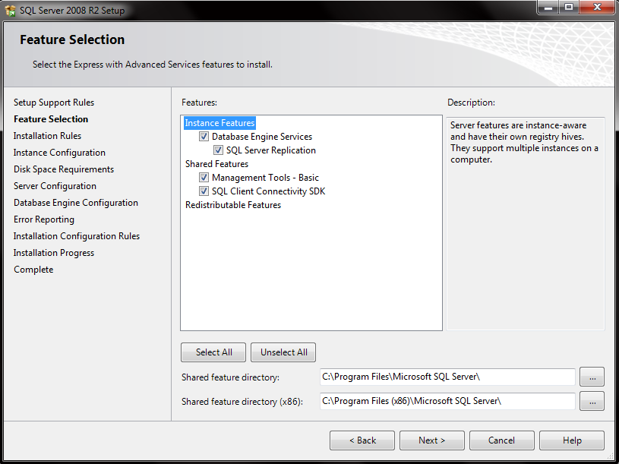

Figure 3.4 Feature Selection of SQL Server Installer

1. Write your instance name and instance ID, instance ID will be your ID at your directory file. You can’t put special character for your instance.

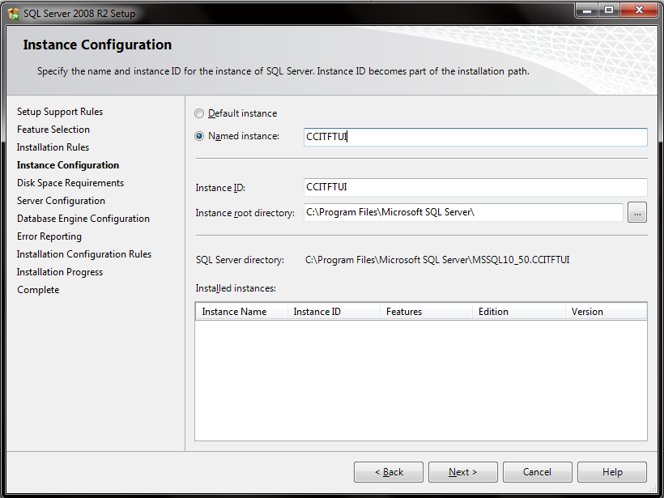

Figure 3.5 Instance Configuration of SQL Server Installer

1. This is Service Account step, make sure you use separate account like Microsoft recommends. If you done, click next.

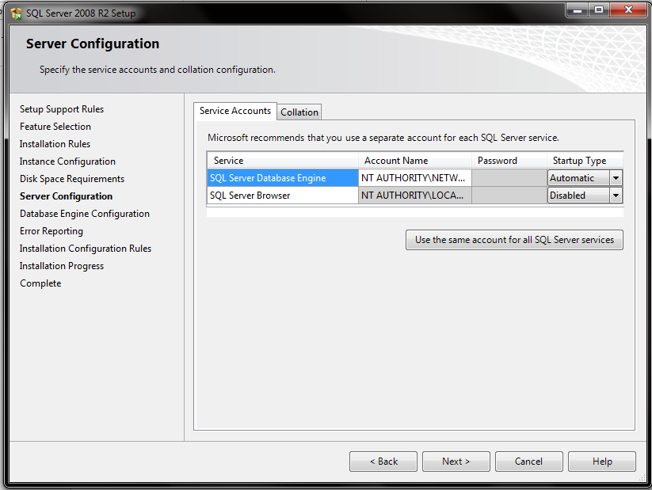

Figure 3.6 Server Configuration of SQL Server Installer

1. In this section you will choose the password for your database. Choose Windows Authentication Mode to let Windows Authenticating when you Log In to your database or make mixed password to make password by yourself. In this section you can choose the user who can use this Database Application.

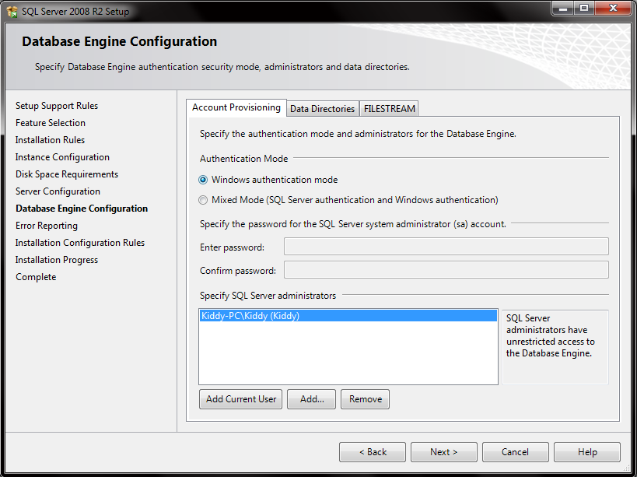

Figure 3.7 Database Engine Configuration of SQL Server Installer

1. You can choose Send Windows Error Report to Microsoft or your Corporate Report Server if something happened to your Database.

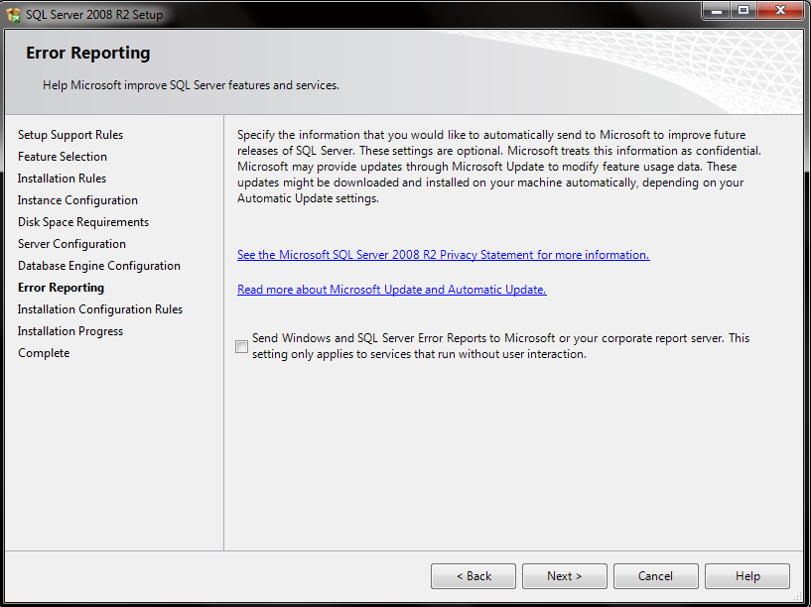

Figure 3.8 Error Reporting Menu of SQL Server Installer

1. Please wait untill installation progress completed.

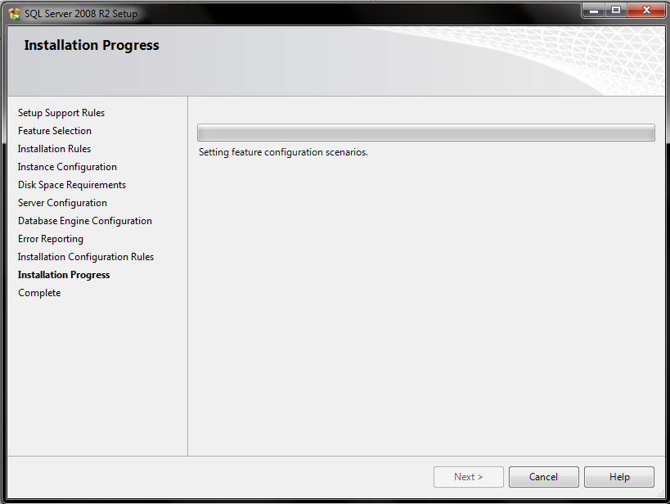

Figure 3.9 Installation Progress of SQL Server Installer

1. Click close when the installation was completed.

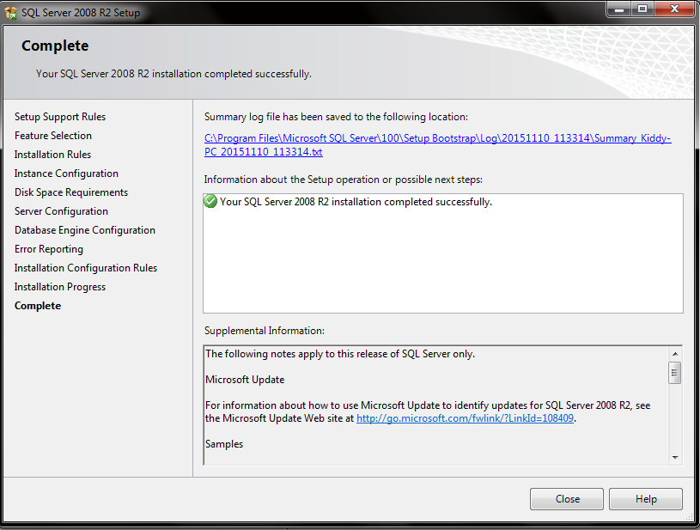

Figure 3.10 Completed Instalation of SQL Server Installer

**III.2 Advantages and Disadvantages of SQL Server**

SQL Server has many excess like:

1. Can create *mirroring* and *clustering*.
2. Has high performance.
3. Centrally control.
4. SQL server has good features.
5. Support many software and Hardware.
6. Simple for user and for client although in installation program.
7. Professional basis data system, get support by Microsoft different from any product.
8. Have data restoration and maintenance features.
9. Have a good management password.
10. SQL server already compatible with any scale labor.
11. Skill control from user and license access to data basis.
12. Have ability to backup, rollback, and recovery data. [5]

SQL server also have a minus like :

1. Not Free.

SQL server are a database server with license, license price also not cheap SQL server feel so heavy to small factory.

1. Just worked on windows platform.
2. Sometimes there a weakness on execute code. [5]

**III.3 Comparison Between SQL Server and MySQL**

SQL Server Advantages:

• SQL Server controlled TPC – C and price.

• SQL server usually easy to installation, using, and controlled.

• Transact – SQL has high rate than MySQL language

MySQL Advantages:

• MySQL support all platform, not just Windows Platform.

• MySQL doesn’t really need much hardware power.

• You can used MySQL free under GNU (General Public License).

SQL Server just working for platform like Windows like Windows 9x, windows NT, Windows 2000 and windows CE.

• My SQL support all platform like, windows, AIX-System, HP-UX System, Linux Intel, Sun Solaris and etc. [6]

And this different specification software support MySQL or SQL server :

MySQL

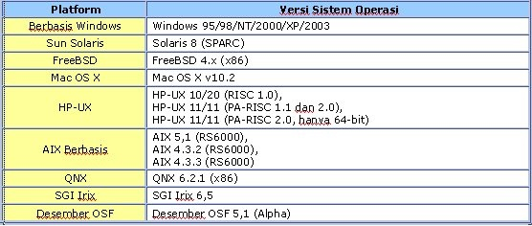

SQL Server

|  |  |  |  |  |  |  |
| --- | --- | --- | --- | --- | --- | --- |
| Operation System | Enterprise Edition | Standar Edition | Personal Edition | Developer | Dekstop Engine | SQL Server TM |
| Windows CE | No | No | No | No | No | Yes |
| Windows 9x | No | No | Yes | No | Yes | No |
| Windows NT 4.0 with Service pack 5 | No | No | Yes | Yes | Yes | No |
| Windows NT 4.0 Server enterprise with service pack 5 | Yes | Yes | Yes | Yes | Yes | No |
| Windows 2000 Professional | No | No | Yes | Yes | Yes | No |
| Windows serer 2000 | Yes | Yes | Yes | Yes | Yes | No |
| Windows 200 Andvanced Server | Yes | Yes | Yes | Yes | Yes | No |
| Windows 2000 internet | Yes | Yes | Yes | Yes | Yes | No |
| Windows XP professional | No | No | Yes | Yes | Yes | No |

[6]